Section 1

Table 1
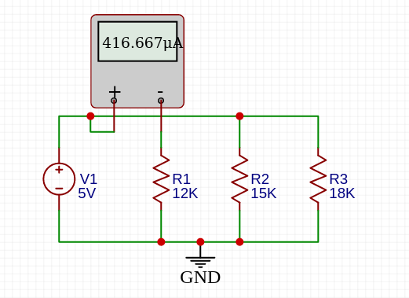I₁[A] 5V

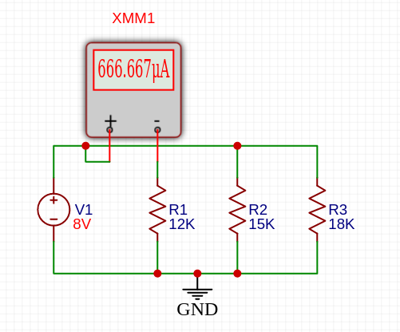
I₁[A] 8V

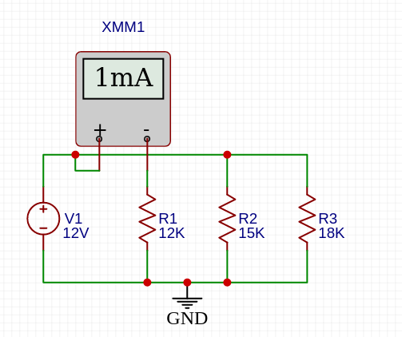
I₁[A] 12V

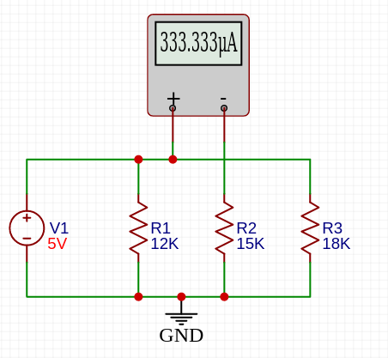
I₂[A] 5V

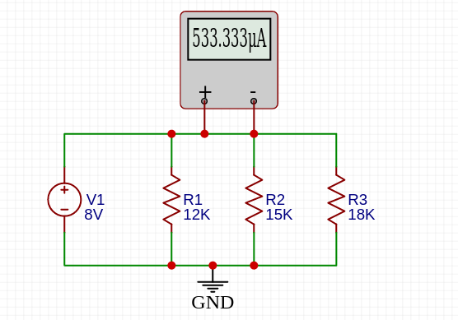
I₂[A] 8V

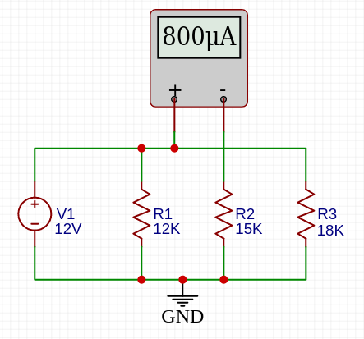
I₂[A] 12V

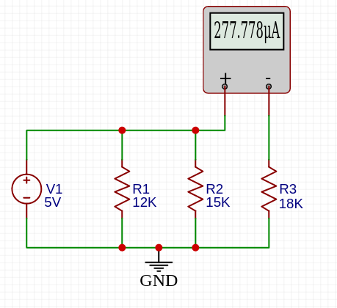I₃[A] 5V

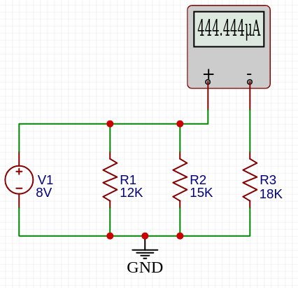
I₃[A] 8V

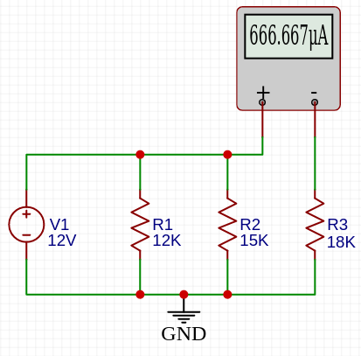I₃[A] 12V

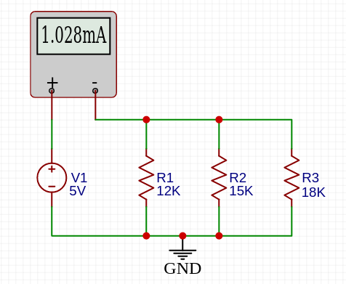
I_{k}[A] 5v

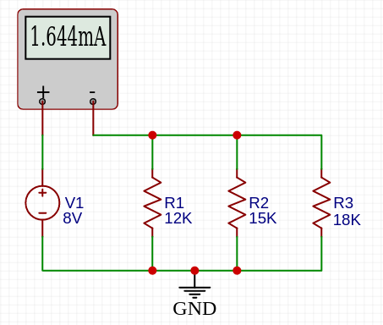I_{k}[A] 8v

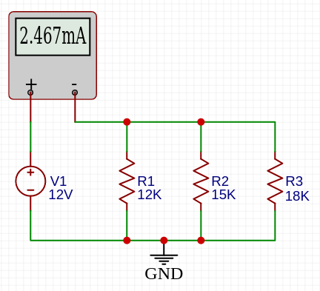
I_{k}[A] 12v

Table 2

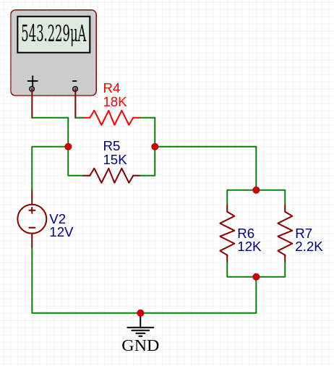
I_{R1}[A]

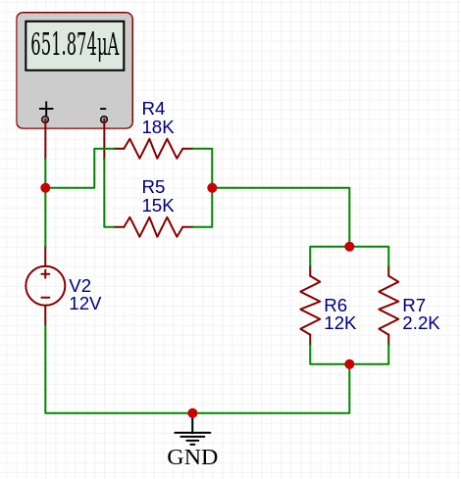
I_{R2}[A]

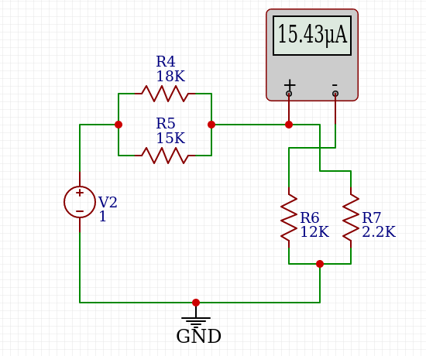
I_{R3}[A]

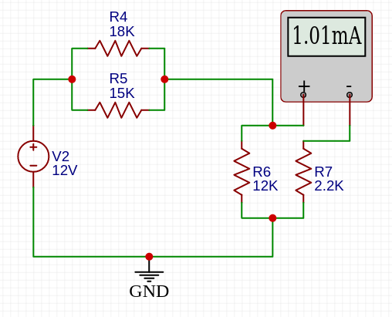
I_{R4}[A]

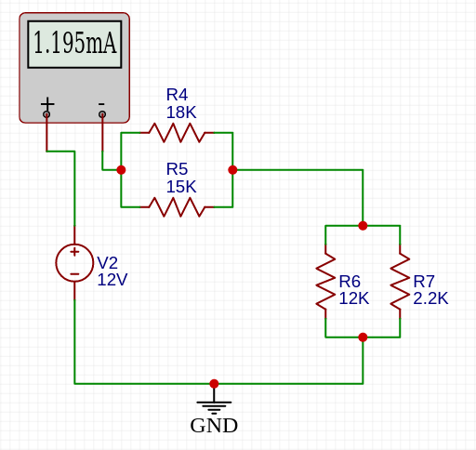
I_{k}[A]

Section 2

Table 3 ( 2.1 )
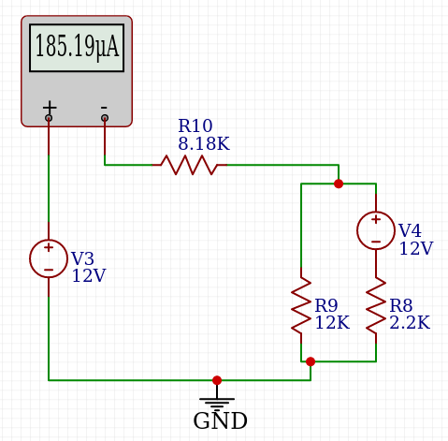
IR1,2eqv[A]

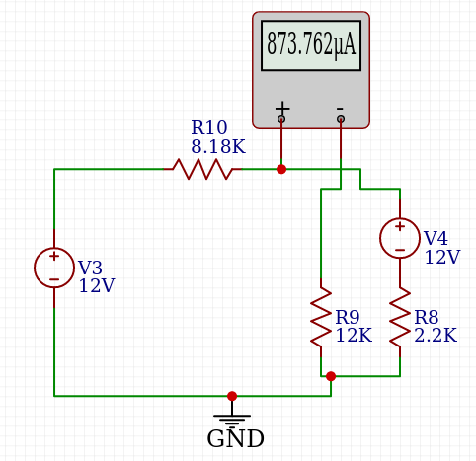
IR3[A]

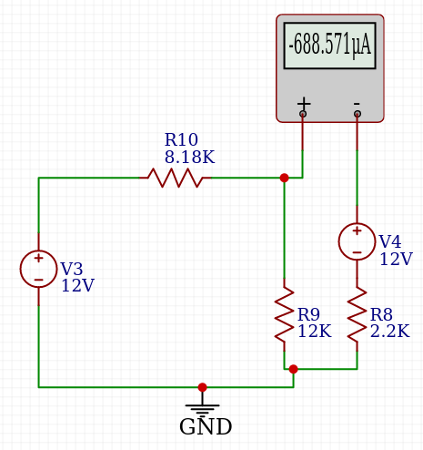
IR4[A]

Table 4 ( 2.2 )

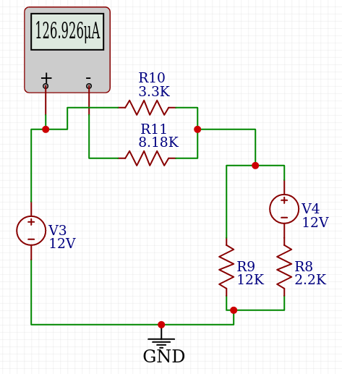
IR1,2eqv[A]

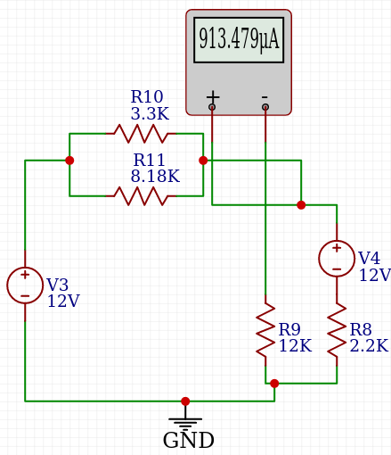
IR3[A]

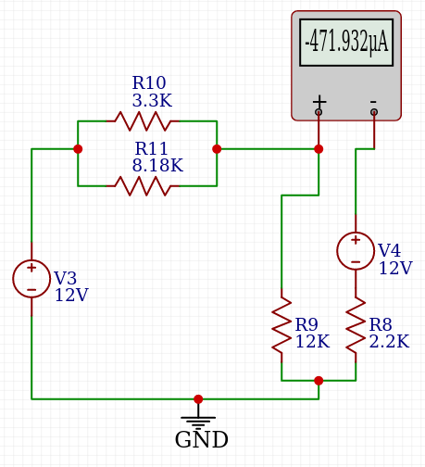
IR4[A]

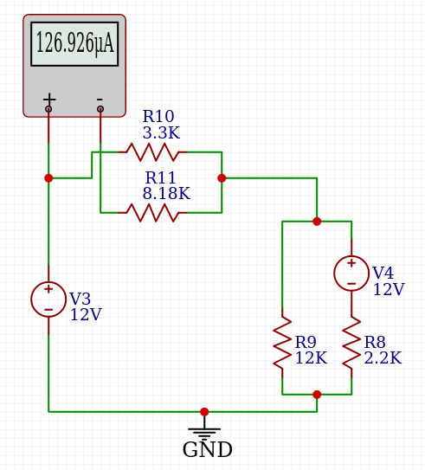
IR5[A]

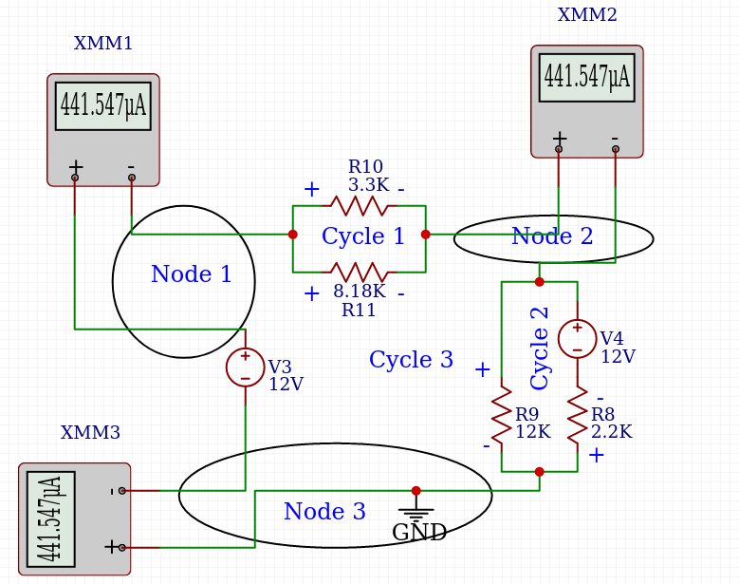
I_{N1}[A] I_{N2}[A] I_{N3}[A]

Table 6

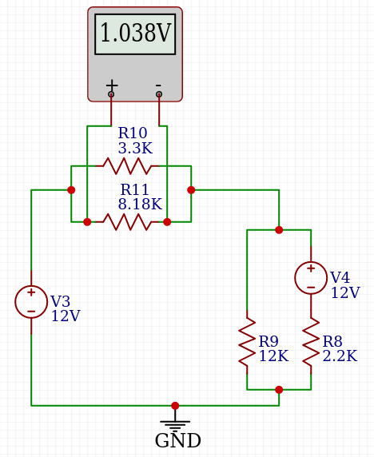
VR1,2eqv[V ]

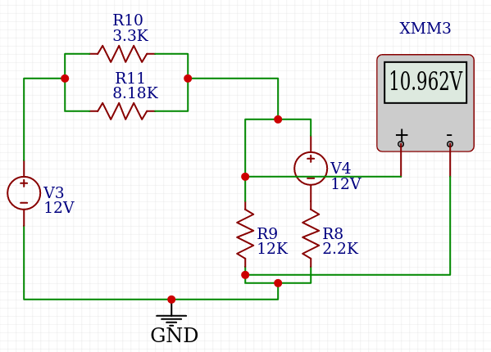
VR3[V ]

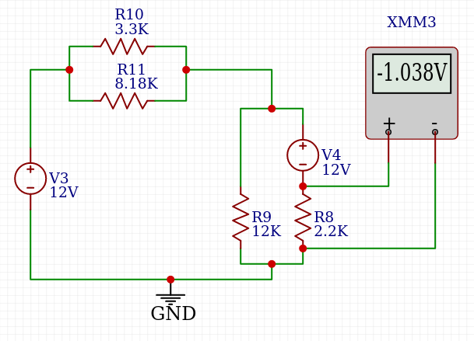
VR4[V ]

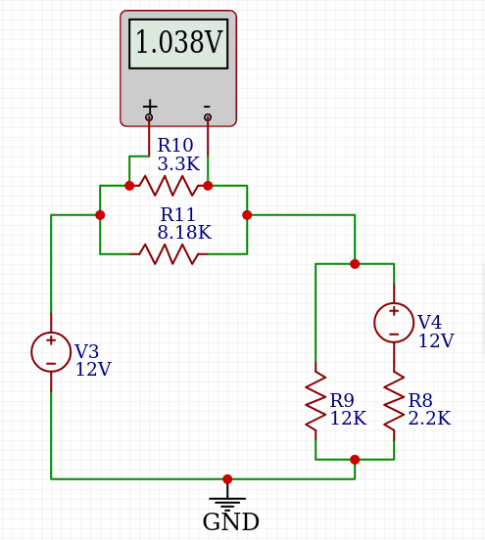
VR5[V ]

Table 7

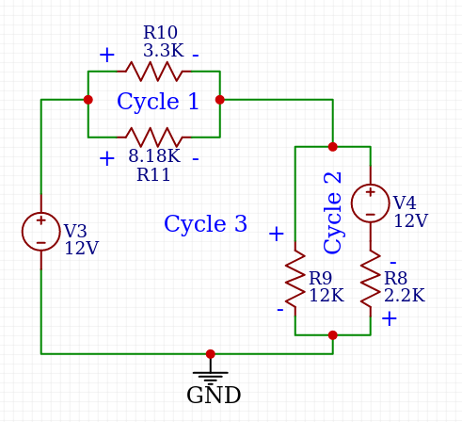
Last Built Circuit

Circuits

Figure 3
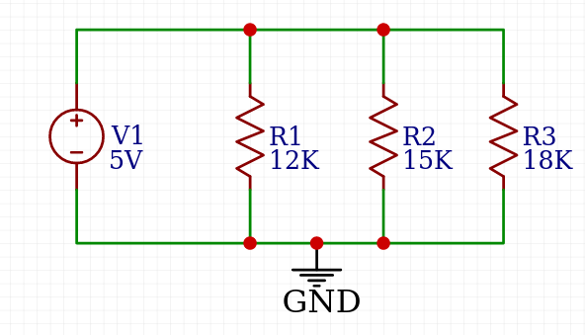

Figure 4
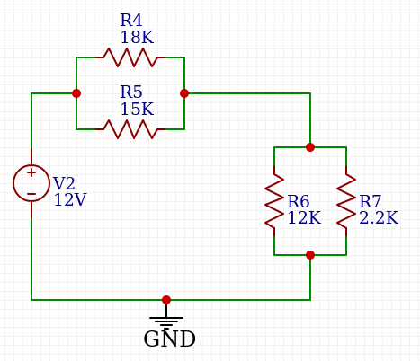

Section 2.1
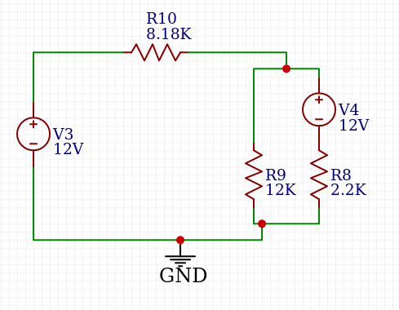

Section 2.2

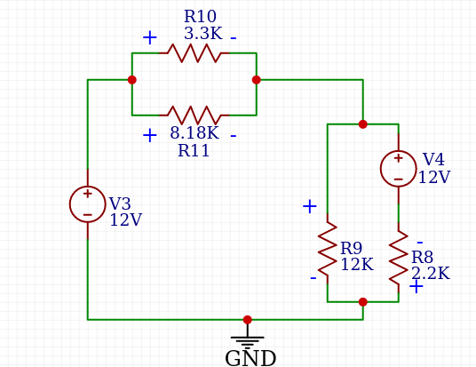

Tables

Vk1 | I₁[A] | I₂[A] | I₃[A] | I₁ + I₂ +  I₃[A] | I_{k}[A]  (Mea- sured) | I_{k}[A]  (Calcu- lated) | Relative  Error [%]
5V | 416.67 μA | 333.3 μA | 277.778μA | 1027,748 μA |  | 1.028mA
8V | 666.67 μA | 533.3 μA | 444.4 μA | 1644,37 μA |  | 1.644mA
12V | 1mA | 800μA | 666.67 μA | 2466,67 μA |  | 2.467mA
Table 1

I_{R1}[A] | I_{R2}[A] | I_{R1} +  I_{R2}[A] | I_{R3}[A] | I_{R4}[A] | I_{R3} +  I_{R4}[A] | I_{k}[A]
543.229μA | 651.874μA | 1195,10 μA | 15.43 μA | 1.01mA | 1025,43 μA | 1.195mA
Table 2

I_{C1}[A] | I_{C2}[A] | IR1,2eqv [A] | I_{R3}[A] | I_{R4}[A]
* | * | 185.168 μA | 873.762μA | -688.571 μA
Table 3
* What is cycle current ? I think it’s a mistake.

I_{N1}[A] | I_{N2}[A] | I_{N3}[A] | IR1,2eqv [A] | I_{R3}[A] | I_{R4}[A] | I_{R5}[A]
441.547μA | 441.547 μA | 441.547 μA | 126.926 μA | 913.479 μA | -471.932 | 126.926 μA
Table 4

Node | 1 | 441uA = 314uA + 126uA
Node | 2 | 441uA = - 471uA + 913uA
Node | 3 | -471uA = -471uA
Node | 4 | -471uA +913uA = 441uA
 |  | Table | 5

VR1,2eqv [V ] | V_{R3}[V ] | V_{R4}[V ] | V_{R5}[V ]
1.038 V | 10.962 V | -1.038 V | 1.038 V
Table 6

Cycle | 1 | + 1.038 - 1.038 = 0
Cycle | 2 | - 10.962 + 12 -1.038 = 0
Cycle | 3 | - 12 + 1.038 + 10.962 = 0
 |  | Table | 7

Mehmet Hüseyin YILDIZ
200104004095
Cse 231 Lab 02

